AWS Task 2

Below are the steps to set up VPC environment and launch a Linux EC2
Overview:
We will create:
- 1 VPC
- 1 Internet Gateway (IGW)
- 1 Public Subnet (/24 → 256 IPs)
- 1 Private Subnet (/24 → 256 IPs)
- 1 Route Table (connected to IGW for public subnet)
- 1 Linux EC2 instance in the public subnet

Step 1: Create a VPC
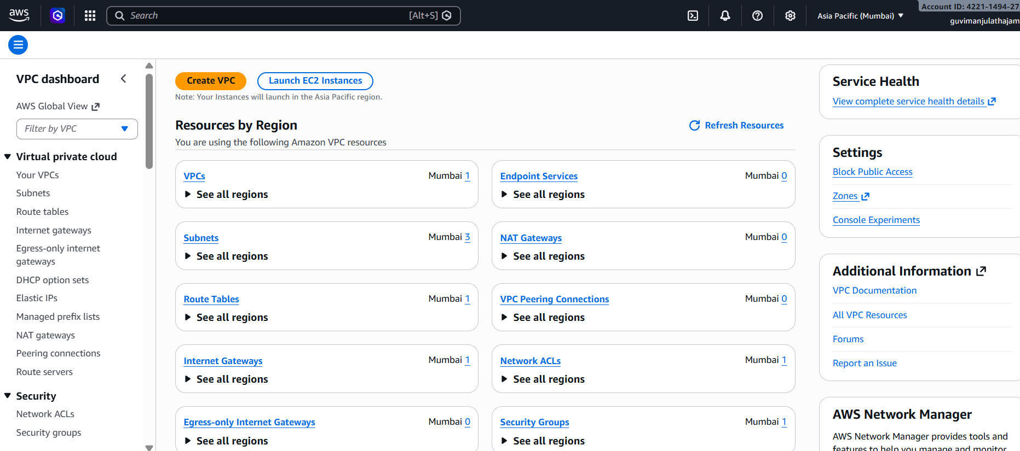
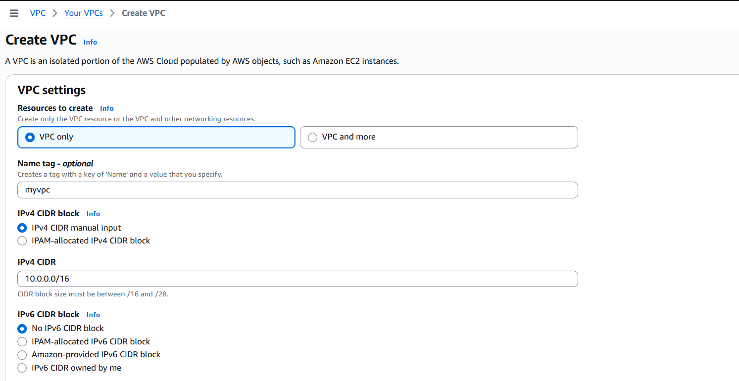
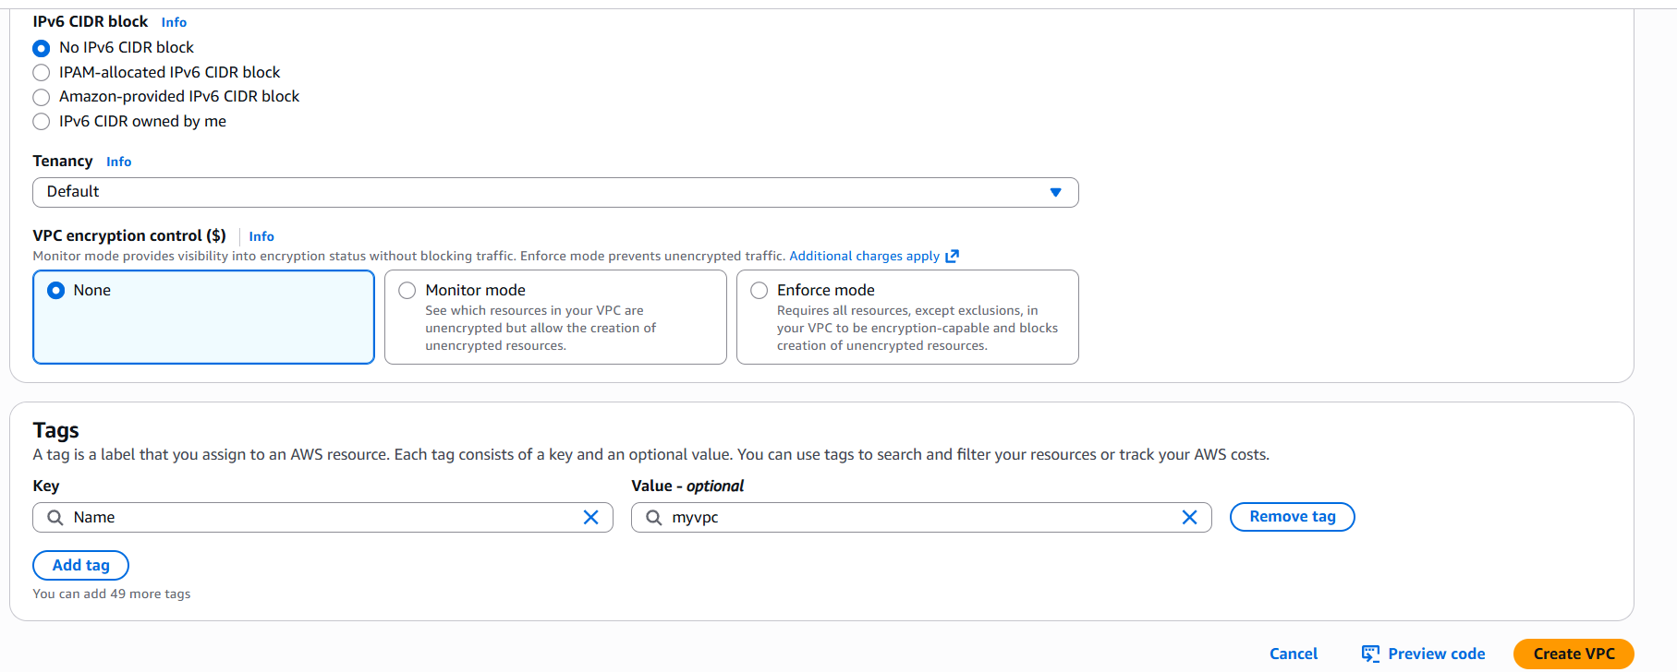
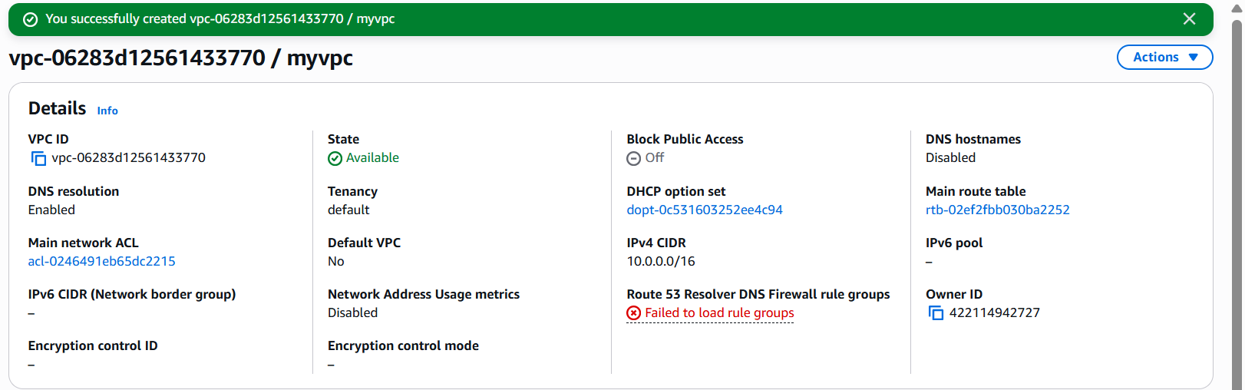

Step 2: Create an Internet Gateway
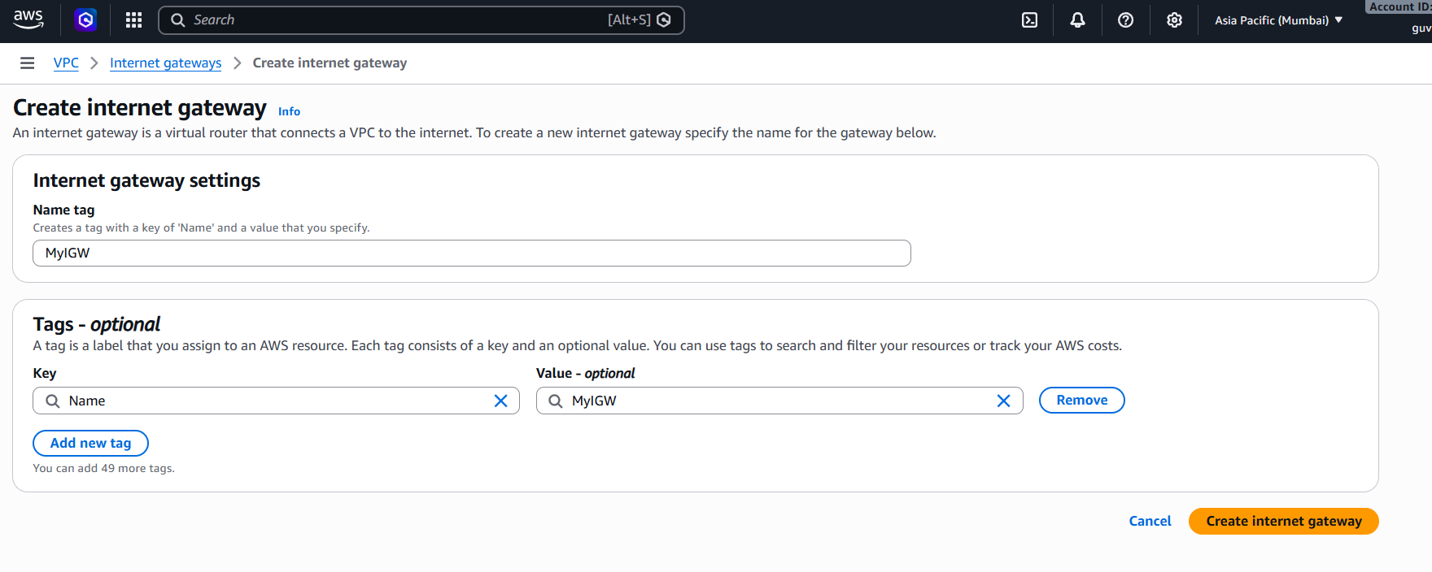
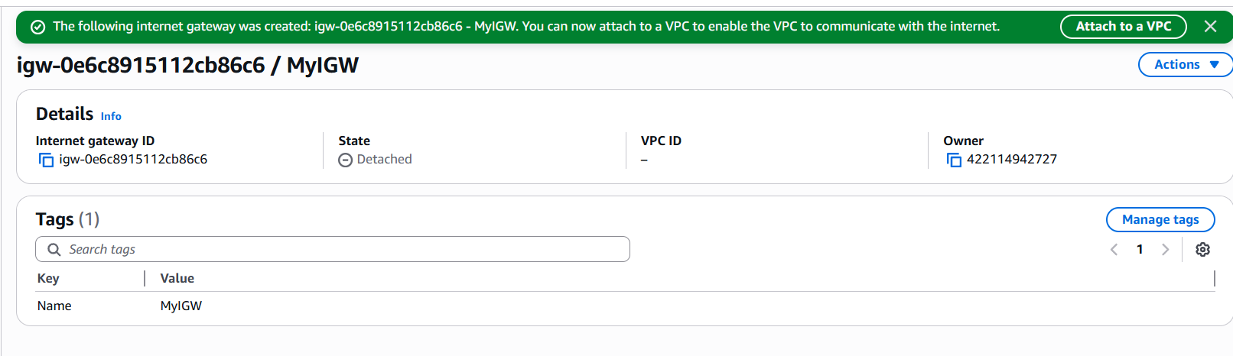
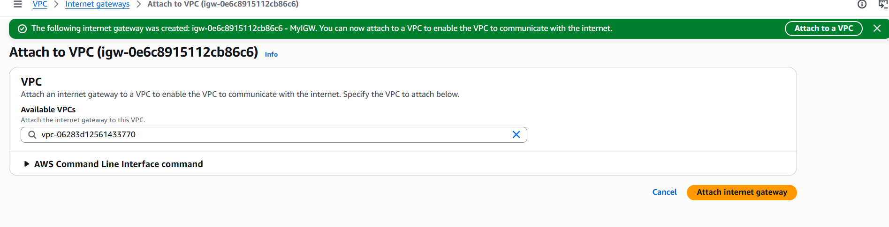
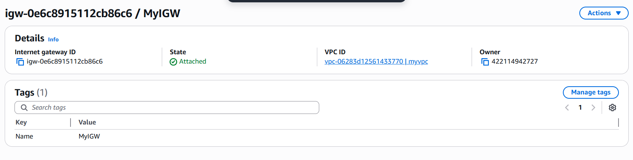

Step 3: Create Public Subnet (256 IPs)
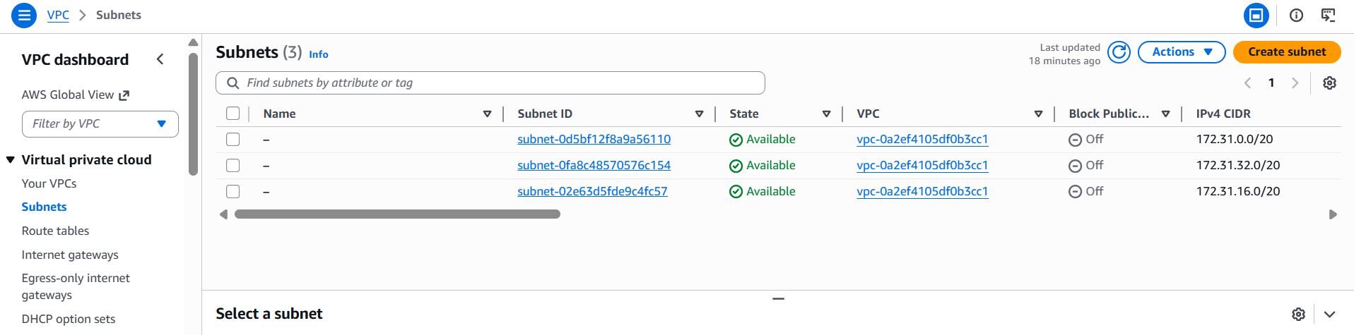
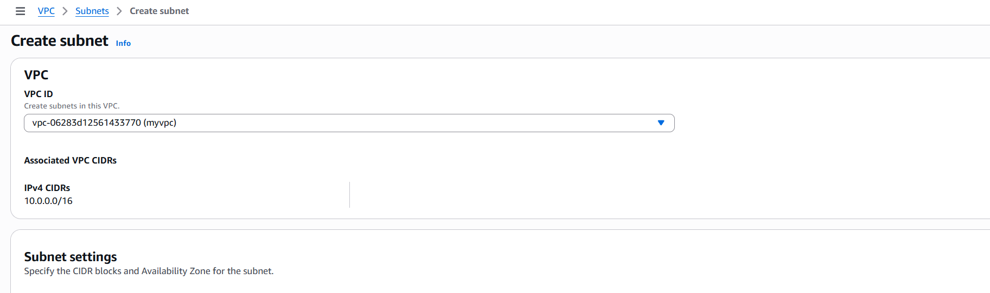
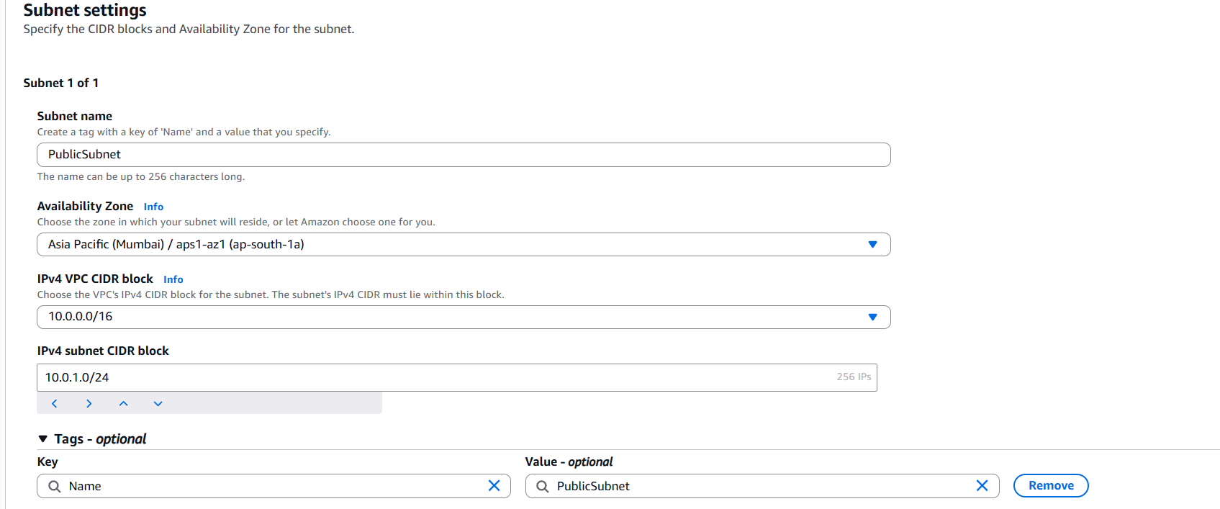
Enable Auto-Assign Public IP
- Select PublicSubnet
- Click Actions → Edit subnet settings
- Enable Auto-assign public IPv4 address
- Save
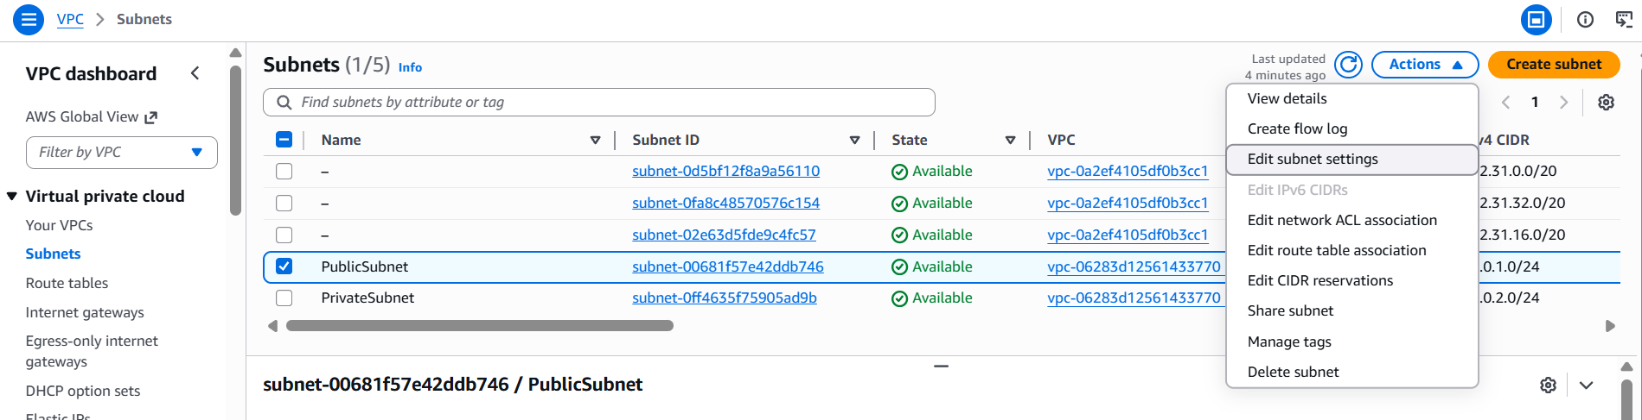
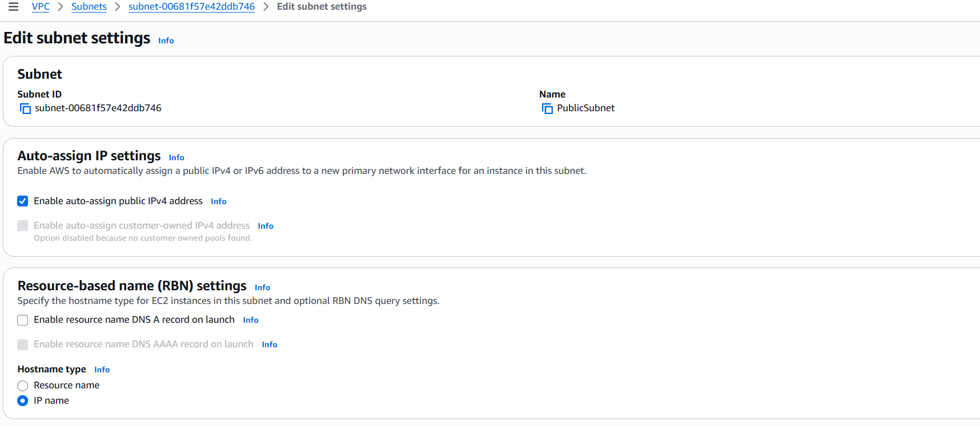

Step 4: Create Private Subnet (256 IPs)
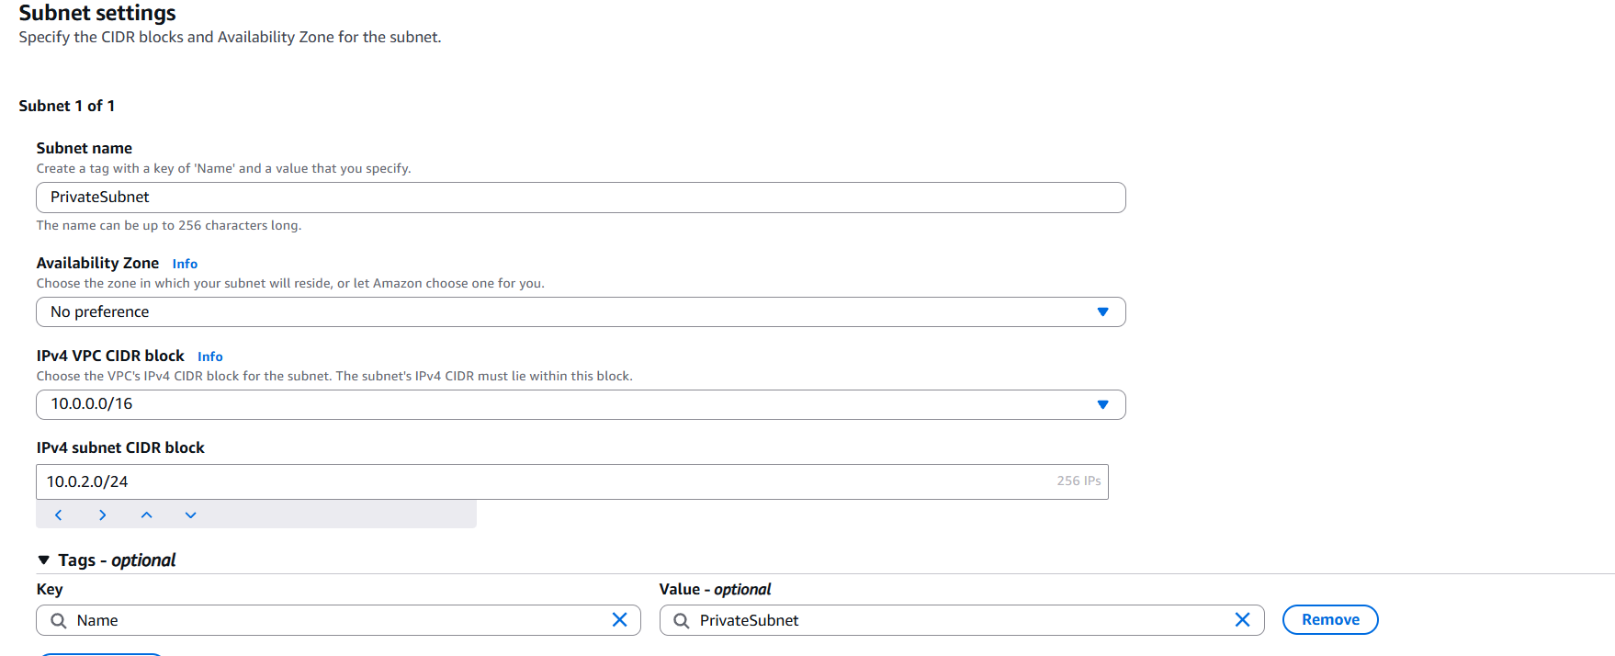
Step 5: Create Route Table for public subnet
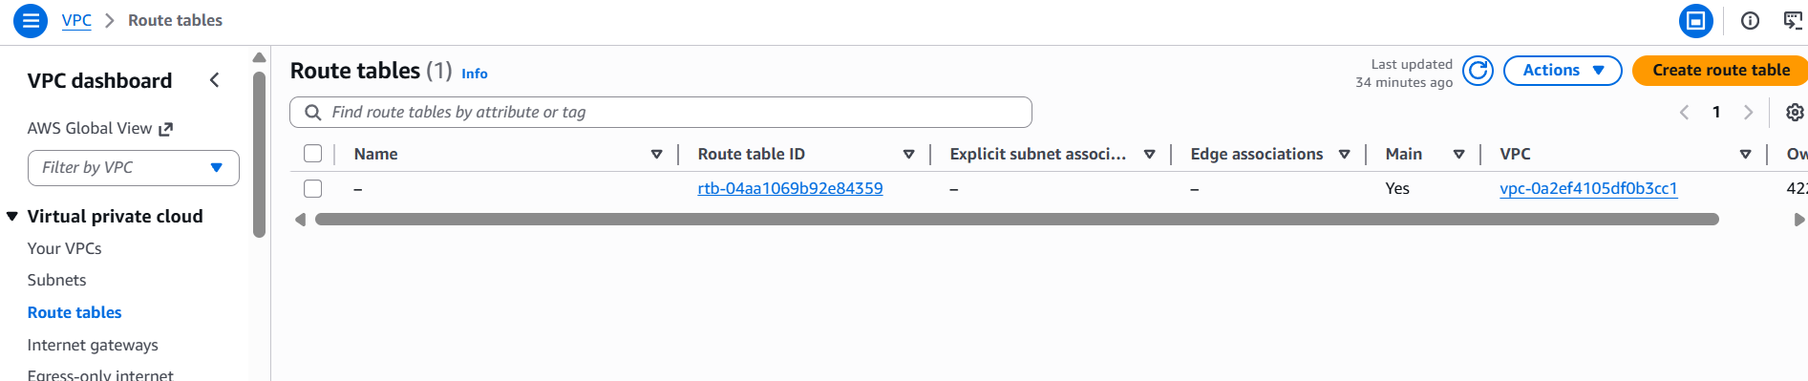
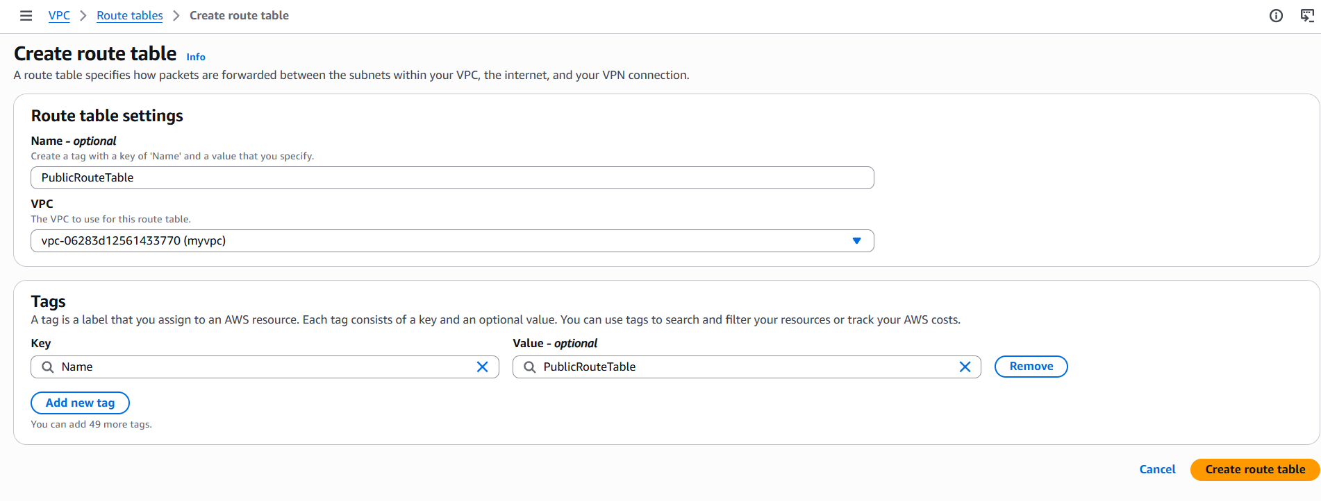
Once Route table is created add Route to Internet
- Select PublicRouteTable
- Go to Routes → Edit routes
- Add route:
  - Destination: 0.0.0.0/0
  - Target: MyIGW
- Save
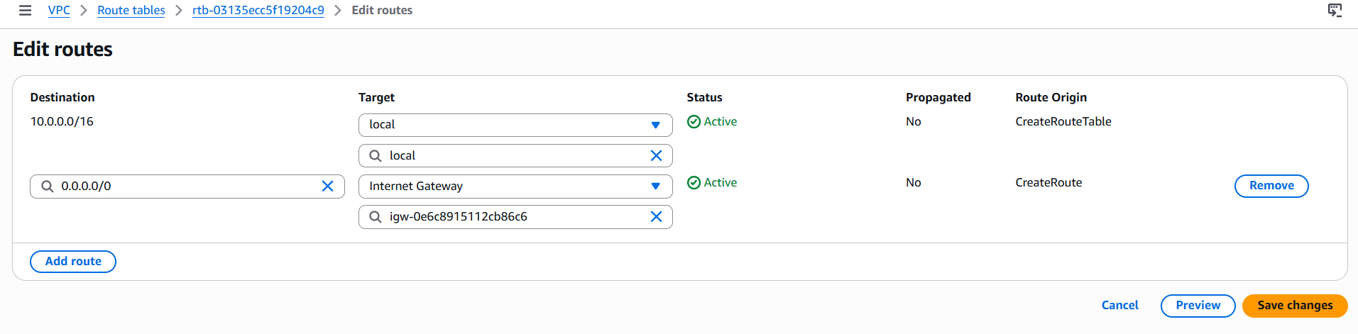Associate Public Subnet
- Go to Subnet associations
- Click Edit subnet associations
- Select PublicSubnet
- Save
👉 Do NOT associate this route table with the private subnet.
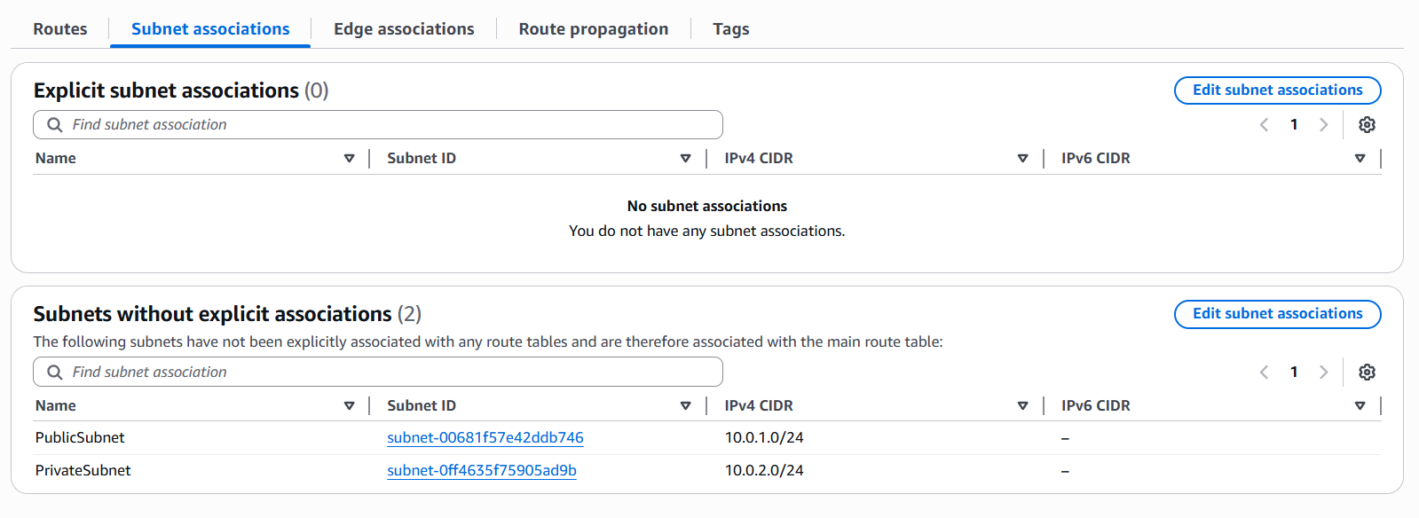
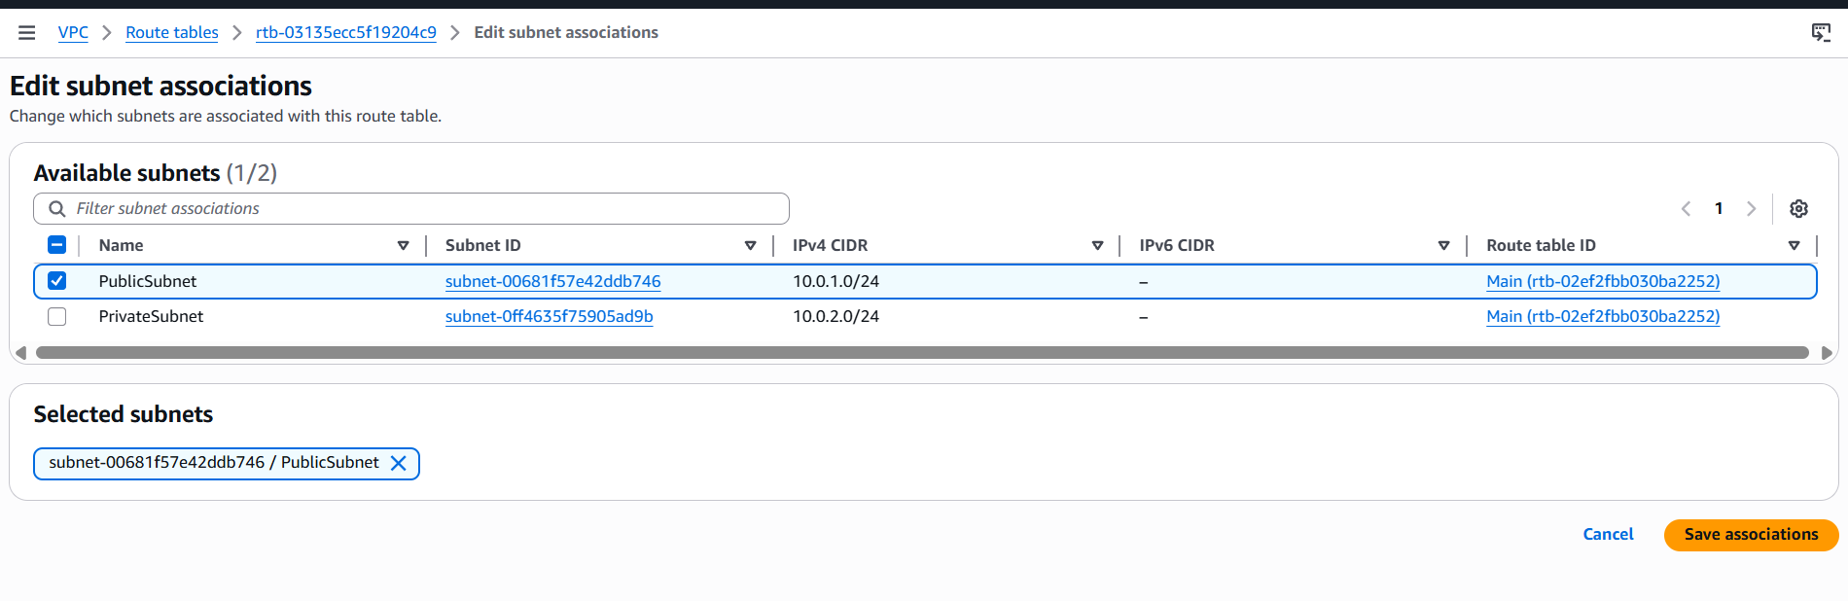
Step 6: Launch Linux EC2 Instance
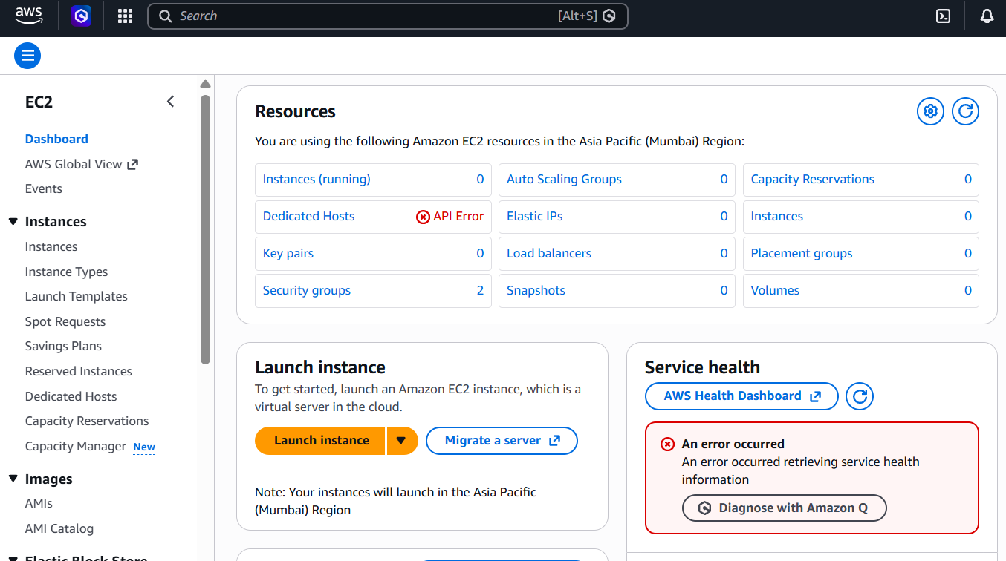
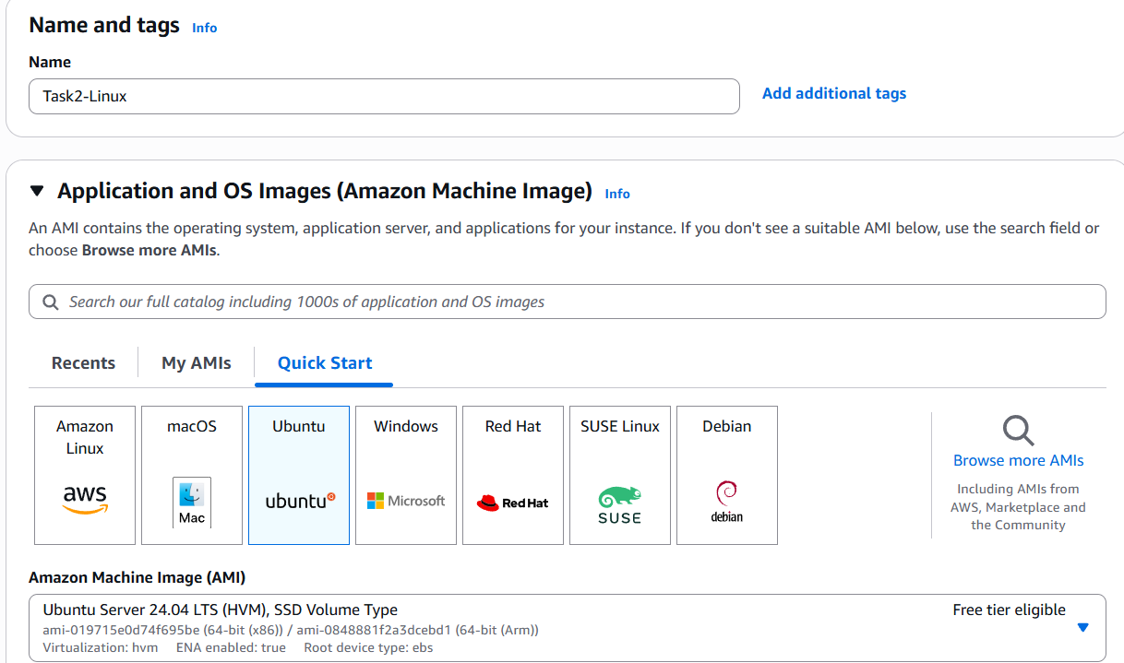
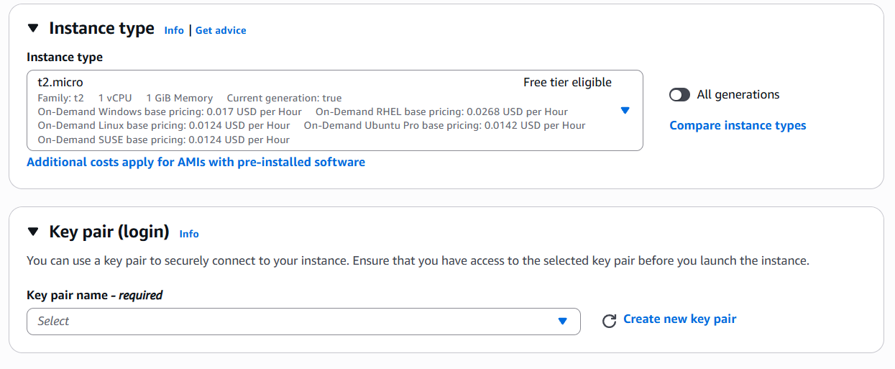
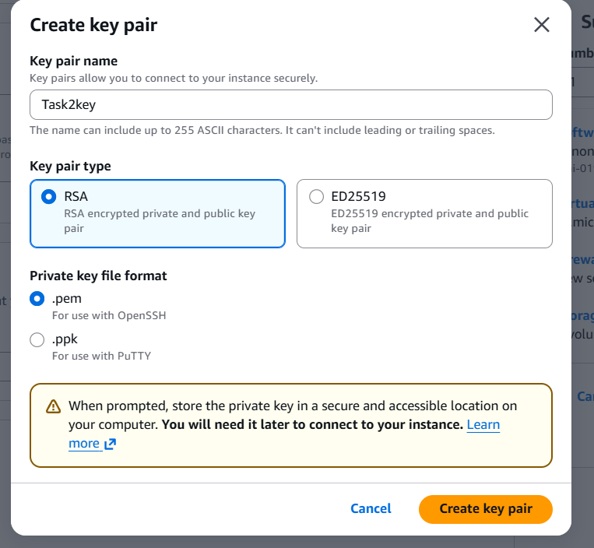
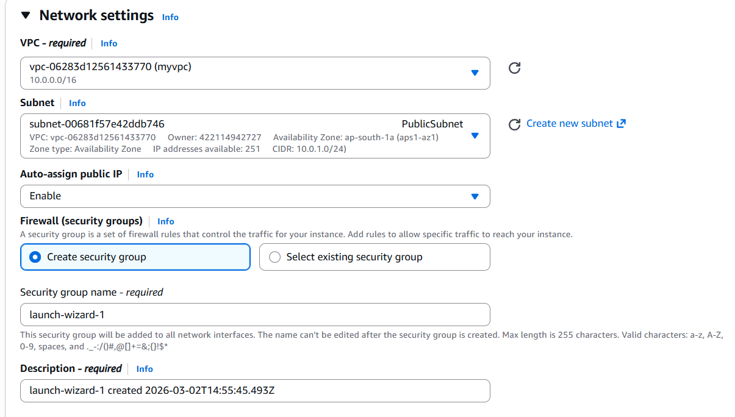
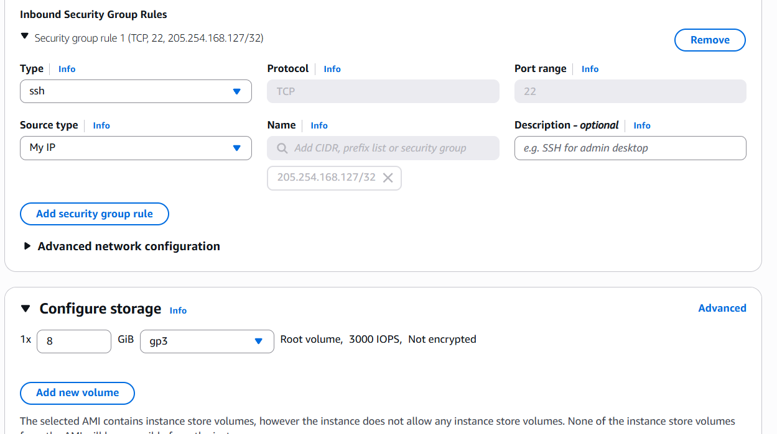
Verify the Setup:
